**ELECTION SYSTEM**

Aaron Samuel (97)

**Aim:**

To develop an electoral voting system where it performs functions such as:

1. To accept the vote casted.
2. To count the vote.
3. To find the leading candidate of the election.

**Overview:**

* **Algorithm**
* **Flowchart**
* **Output**

**Algorithm:**

**Step 1 –** Start

**Step 2 –** Declare variables name, candidate name, candidate count and choice of the candidate.

**Step 3 –** Display “Welcome to United States Election 2020“as the heading and display voting options.

1. Cast the Vote
2. Find Vote count
3. Find leading candidate
4. Exit

**Step 4 –** Read input data in variables name, candidate name, candidate count and choice of the candidate.

**Step 5 –** Take a number “n” as input and whether it is between 0 and 3 are equal.

**Step 6 –** For n=1 (Cast the vote), display “Please enter your choice”. Then read the input data given to these variables and store it in system. Then display “Input your choice (1-5) : “

Return to menu after finishing operation.

**Step 7 –** For n=2 (Find vote count), print “Voting statistics as of now” and all data stored in the system.

Return to menu after finishing operation.

**Step 8 –** For n=3 (Find leading candidate), print “Leading candidate” as per data stored in the system.

If there is no data in the system then print “There is no Leading candidate as of now”.

Return to menu after finishing operation.

**Step 9 –** For n=0(Exit), exit from United States Election 2020

**Step 10 –** Stop

**Flow Chart:**

**Legend:**

**Decision**

**Order of Program**

**Process**

**Display which user can read**

**Input/Output**

**DISPLAY**

**WELCOME TO UNITED SATES ELECTION 2020**

1. **Cast the vote**
2. **Find Vote Count**
3. **Find leading Candidate**
4. **Exit**

**Input n=1**

**Please choose your candidate :**

**1 George Bush**

**2 Barack Obama**

**3 Joe Biden**

**4 Donald Trump**

**5 None of These**

**Input n=2**

**Voting Statistics**

**George Bush –**

**Barack Obama –**

**Joe Biden –**

**Donald Trump –**

**Spoiled Votes –**

**Input n=3**

**If data is printed in the system:**

**Leading Candidate**

**[…..]**

**If data is not printed into the system (or) two variables has same no. of data:**

**There is No Leading candidate as of now !!**

**Input n=0**

**Error: Invalid Choice**

**Pseudocode :**

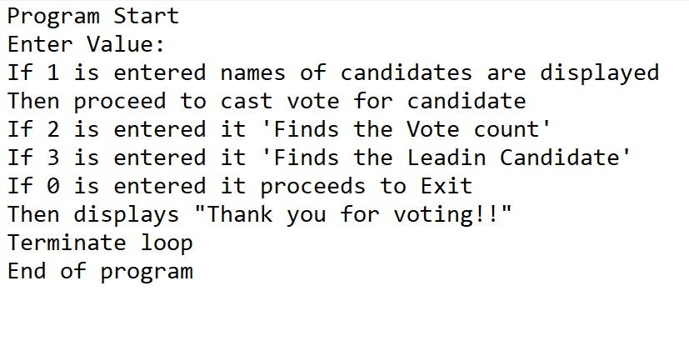

**Program:**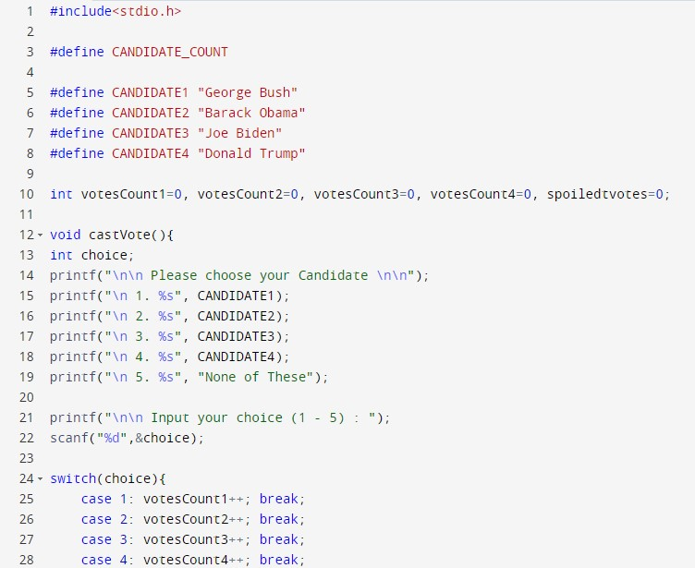

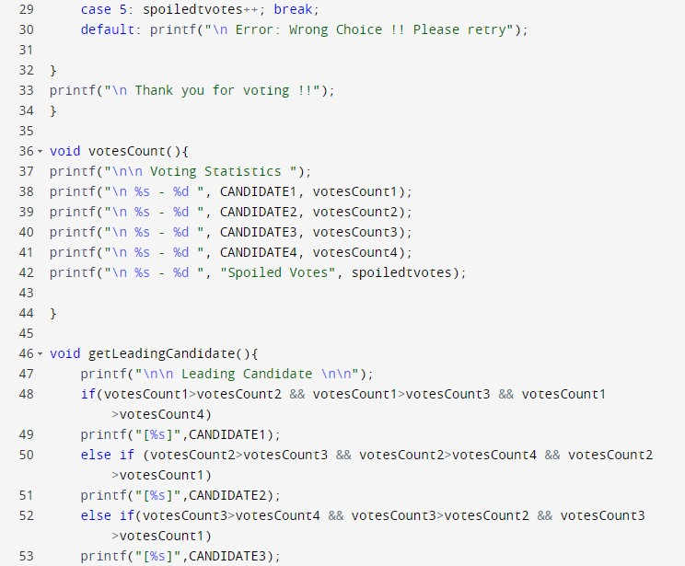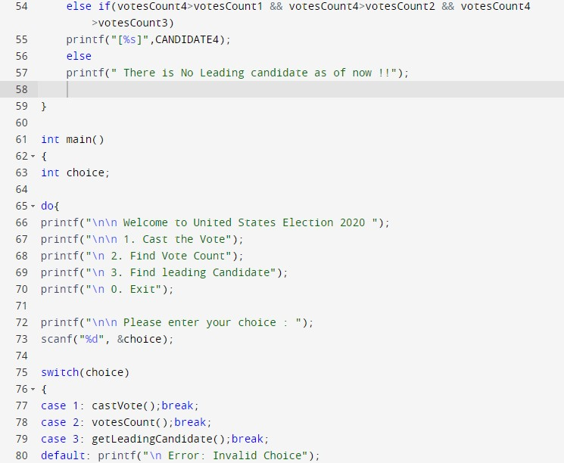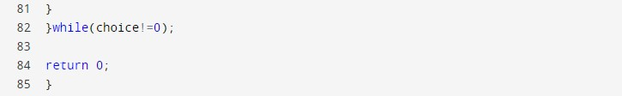

**Output:**

1. For input n=1

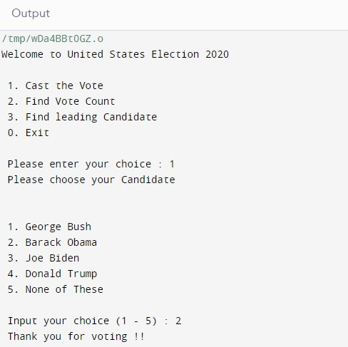

1. For input n=2

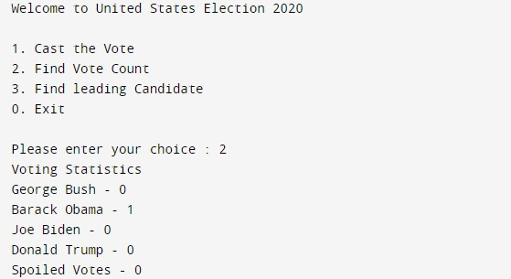

1. For input n=3

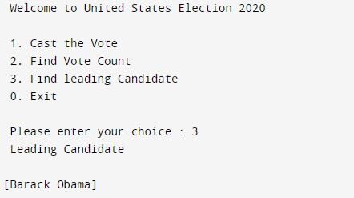

1. For input n=0

